\*\*For checking the broken links, you will need to do the following steps

. 1. Collect all the links in the web page based on "a" and "img" tags.

2. Send HTTP request for the link and read HTTP response code.

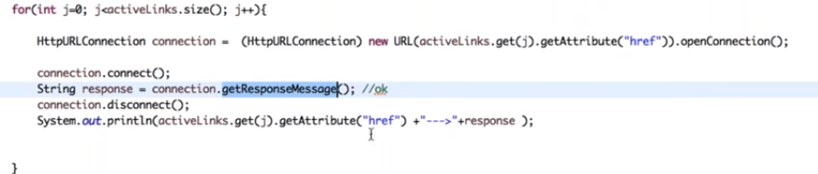

3. Find out whether the link is valid or broken based on HTTP response code.

4. Repeat this for all the links captured.

// for links – a tag there should be ’ href ’, if it there and its not working properly or given wrong URL in href means consider as broken link.

When applications has ‘ a ‘ tags but didn’t used ‘ href ‘ inside means, we wont consider it as broken link and we wont check them also

So check for active links = means which have href attribute

Sometimes you may get javascript written links

Eg:

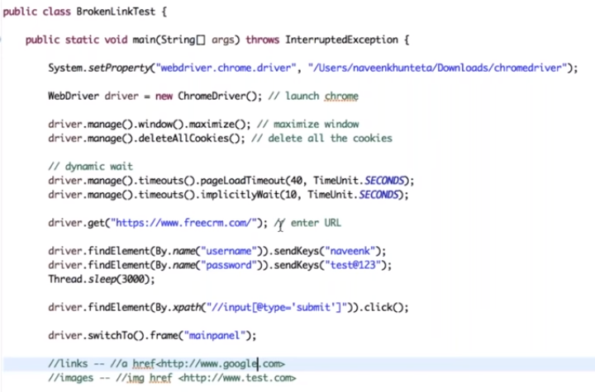

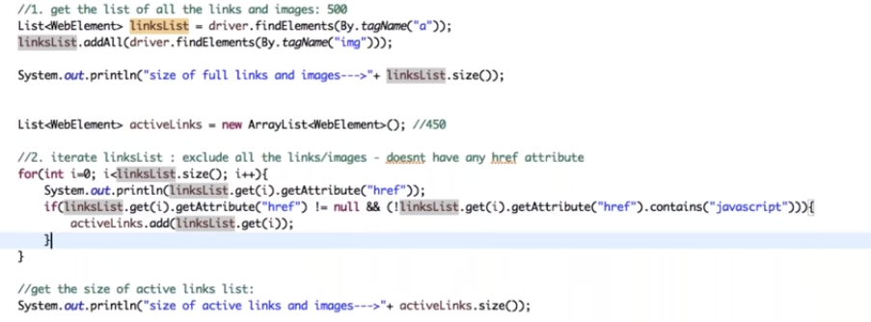

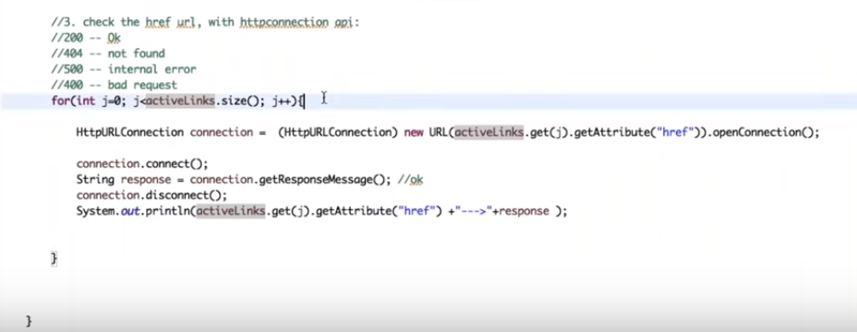

Output

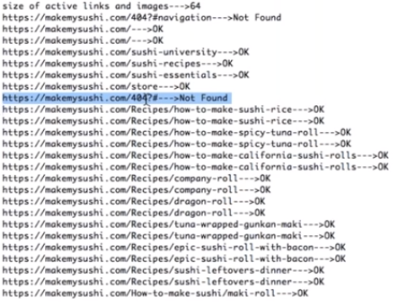

By coping the Not Found link, u can raise bug and send to developer. It will be easy for them to fix it.

It’s a tester responsibility to check all the links and images. Logo img… etc there may be some important links